
Why should I get a server?

Does your team share files and information through e-mail? When you are updating a sales proposal from the road can you get to the latest copy at 2 am? Tired of buying personal printers for every employee in the office? If you’ve answered yes to any of these questions it may be time for a server.


The Benefits of the Microsoft Windows Server Family
" Windows Small Business Server 2008 will help us run the company a lot quicker, so we can focus less time with technical problems and more on how to grow the company.”
Sheryl Chinowth, CEO/Broker/Owner
Chinowth & Cohen Realtors
Help your employees be more efficient and more secure, helping you to get more done, portray a professional image to your customers, saving you time and money.
- Organize information in a central location to easily and securely access the right information when you need it.
- Stay connected to your business and customers from virtually anywhere.
- Protect your business information from disaster or theft.
- Improve employee productivity by securely sharing resources such as printers, files, and business applications with confidence that information is exposed only to those you wish.

About <Partner insert company name/logo here>
Choosing the right solution for your business is too important to leave to chance. We are a Microsoft certified [partner, you can add in SBS certified as well, if appropriate] partner with experience helping companies like yours select and implement serversolutions to help your business be even more successful. [Partner, please revise this section as appropriate to describe your company’s products and services. Try and keep to 50 words.]

Get Started Today!
[We/Company name] recommend[s] genuine [specific Microsoft® product or Microsoft® software].
[Partner, insert your contact information here. You may also want to include brief info about any special deals or promotions you are offering. Try and keep to 25 words.]

Selecting a Server for your Business
How many PC or laptop or users do you have (and expect to have in the next two years)? Do employees need a way to share information and collaborate securely from anywhere? After an initial assessment, we can help you better understand the products and decide on the best solution for your business.
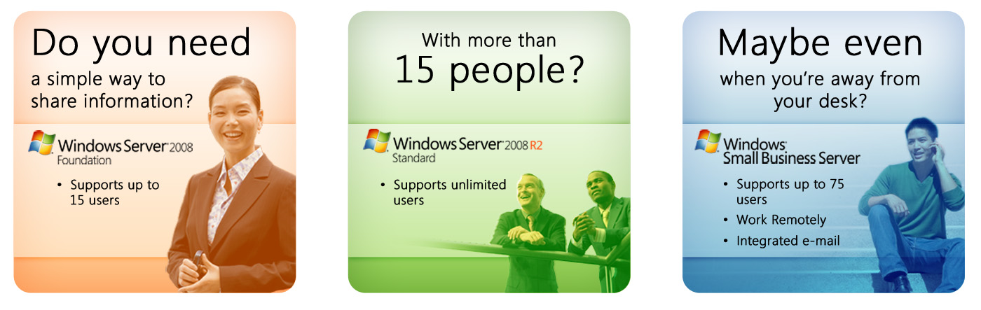

Use the following table for more information about Windows Server technologies.
Microsoft Products | Key Benefits | Number of Users  Each SKU supports
Windows Server 2008 R2 Foundation | Entry level server operating system for running business applications and sharing information and resources. | Up to 15 users
Windows Server 2008 R2 Standard | Advanced server operating system with built-in virtualization capabilities for increased reliability and security. | Unlimited Users
Windows Small Business Server 2008 | All-in-one server solution for better data security, enhanced productivity, and a more professional business image (Microsoft SQL Server available for premium features). | Up to 75 users
Windows Essential Business Server 2008 | Designed and priced for midsize businesses, it helps improve IT manageability and reliability, and helps boost business productivity and growth. (Microsoft SQL Server available for premium features). | Up to 300 users
Windows Server 2008 R2 Enterprise | Enterprise-class server platform for deploying business-critical applications. Provides the foundation for a highly dynamic, scalable IT infrastructure. | Unlimited Users

