
Is it Time to Upgrade Your Servers?


Do you have increasingly mobile employees who need access to your line-of-business applications from various locations? You may also have servers that support various capabilities or roles, but are inefficient to manage because they are not well integrated. Or maybe your current servers are no longer under warranty or running software with support that will be ending soon. You need a simpler way to deploy and administer servers to reduce the time it takes to install, configure, or remove roles.
" With Windows Small Business Server 2008, we can do more with the people we have and at the same time increase customer loyalty. Our productivity and customer service are going up, which helps us grow the business."
Tom Brooks, Owner
Carson Valley Golf Course

The Benefits of Upgrading Your Windows Server Solution
Help your business save time and money by improving employee productivity and operational efficiency. By upgrading your servers to a latest Windows Server offering, you get an IT environment that is more secure by default and simpler to manage.
- Help protect your business with servers that are more secure by default and easier to keep updated.
- Reduce server sprawl to simplify IT management and optimize operations through consolidation and virtualization.
- Easily enable employees to work from home, on the road or from a branch office location more effectively.

About <Partner insert company name/logo here>
Choosing the right solution for your business is too important to leave to chance. We are a Microsoft certified [partner, you can add in SBS certified as well, if appropriate] partner with experience helping companies like yours select and implement servers and solutions to help your business be even more successful.
[Partner revise this section as appropriate to speak more specifically about your company. Try and keep to 50 words.]

Get Started Today!
[We/Company name] recommend[s] genuine [specific Microsoft® product or Microsoft® software].
[Partner, insert your contact information here. You may also want to include brief info about any special deals or promotions you are offering. Try and keep to 25 words.]

Selecting the Right Server Solution
We can help you select the right server. Working together, we can use the chart below to walk through your server requirements and make the right choice for your business. The key decision points depend on your expected company size in the next two years, and your need for:

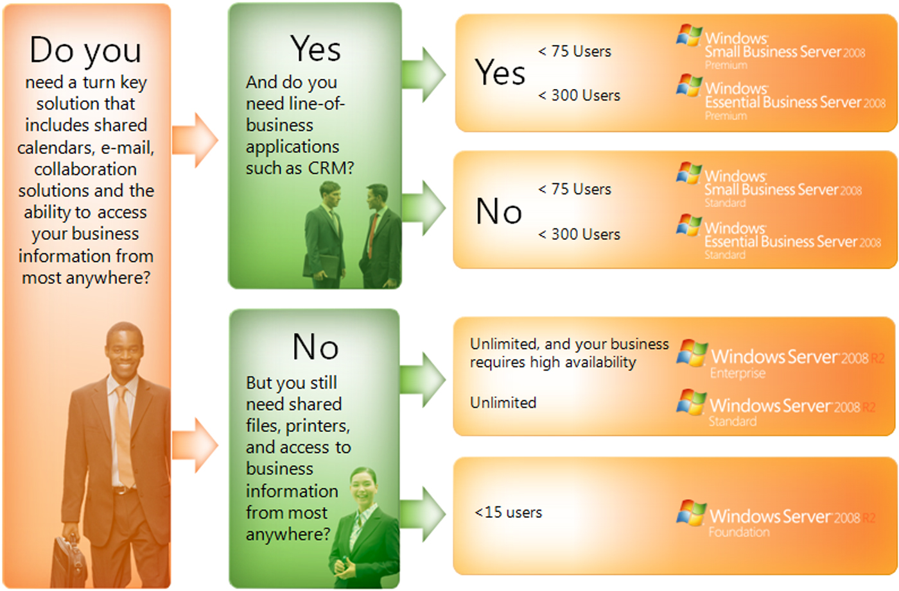

The following table offers more information about Windows Server technologies.
Product | Key Benefits | Number of Users  Each SKU supports
Windows Server 2008 R2 Foundation | Entry level server operating system for running business applications and sharing information and resources. | Up to 15 users
Windows Server 2008 R2 Standard | Advanced server operating system with built in virtualization capabilities for increased reliability and security. | Unlimited Users
Windows Small Business Server 2008 | All-in-one server solution for better data security, enhanced productivity, and a more professional business image (Microsoft SQL Server available for premium features). | Up to 75 users
Windows Essential Business Server 2008 | Designed and priced for midsize businesses, it helps improve IT manageability and reliability, and helps boost business productivity and growth. (Microsoft SQL Server available for premium features). | Up to 300 users
Windows Server 2008 R2 Enterprise | Enterprise-class server platform for deploying business-critical applications. Provides the foundation for a highly dynamic, scalable IT infrastructure. | Unlimited Users

